**---How Publish and Host Our Mvc Core Application(8.0) Step by step on Local Server(For Testing)—**

Process -1 : For Hosting Web Service on II

**Step : 1 - Hold**  **Windows key and press ‘ R ‘.**

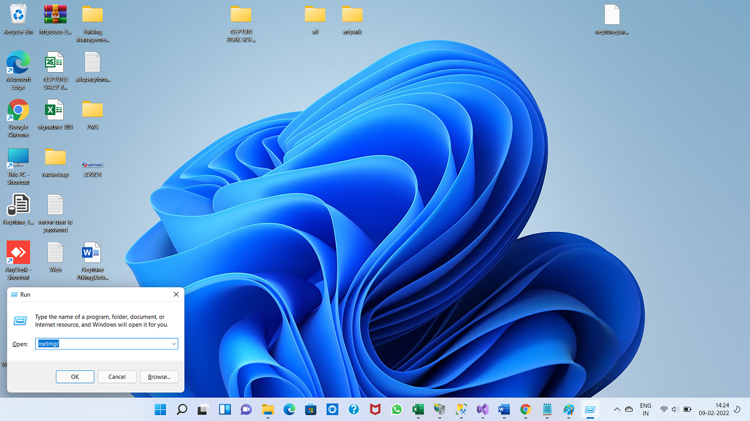**Step : 2 – Click on site to make new Host Application.**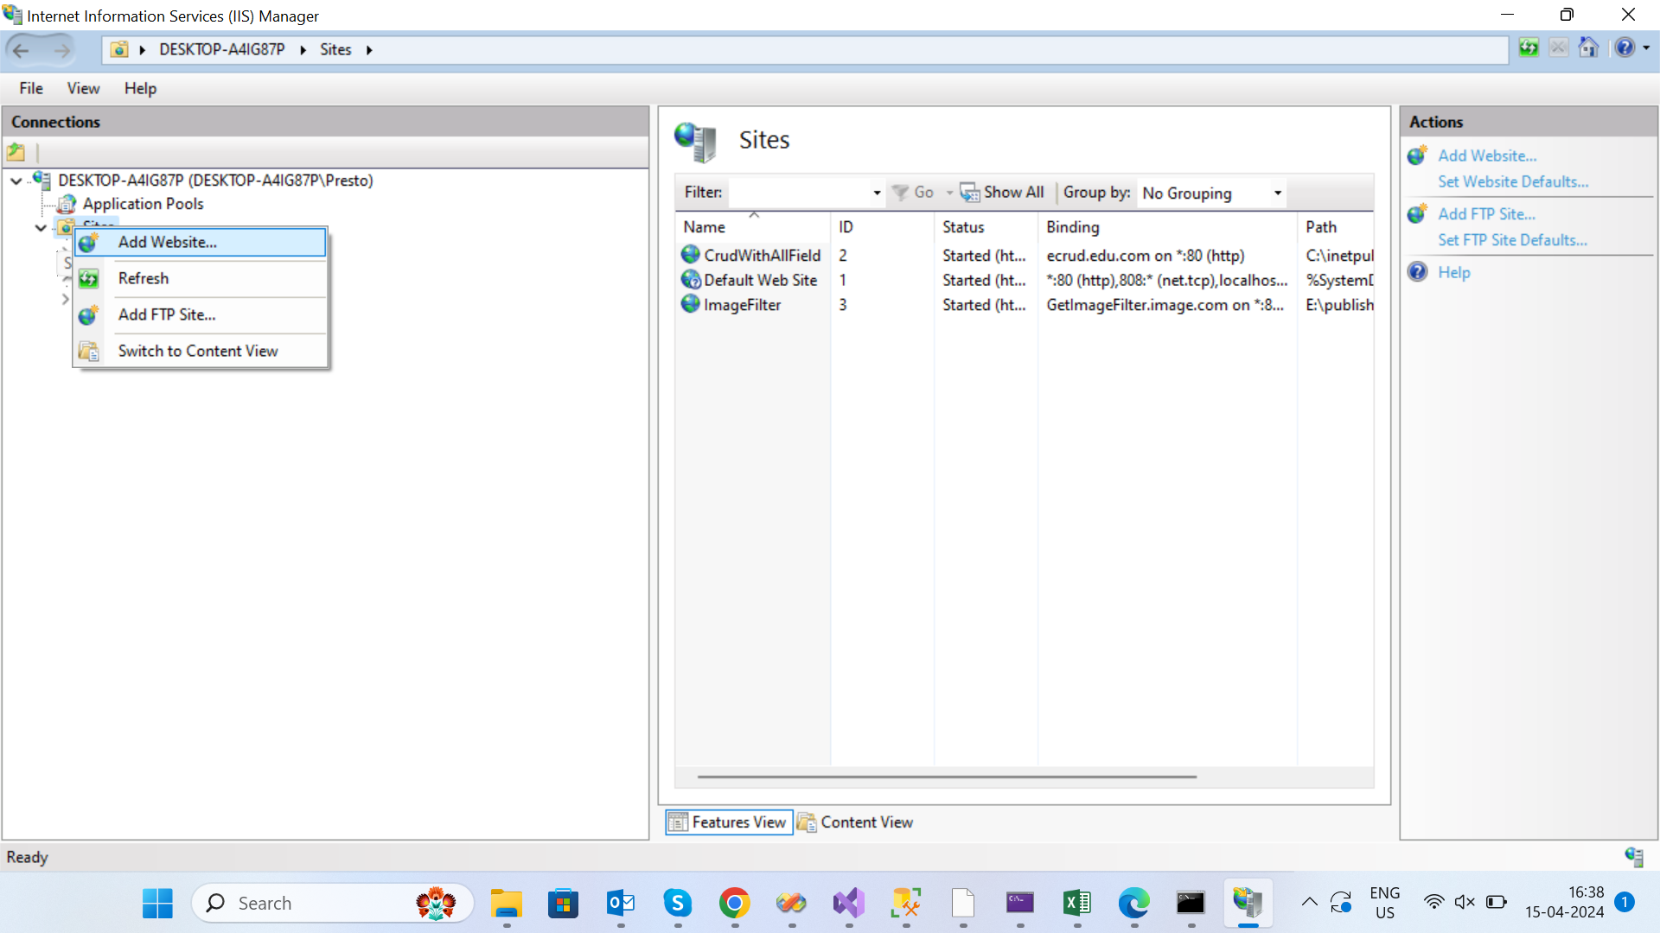

**Step : 3 – Make new Application with any name Like CurdWithAllField.**

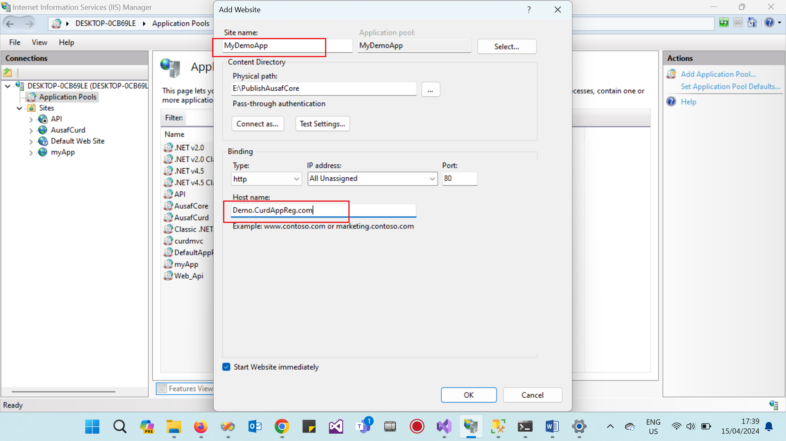

**Step : 4 –Go to c:windows/system32/drivers/etc {select dropdown all file of bottom menu}/open hosts file in notepad to Add IP number and url name like this.**

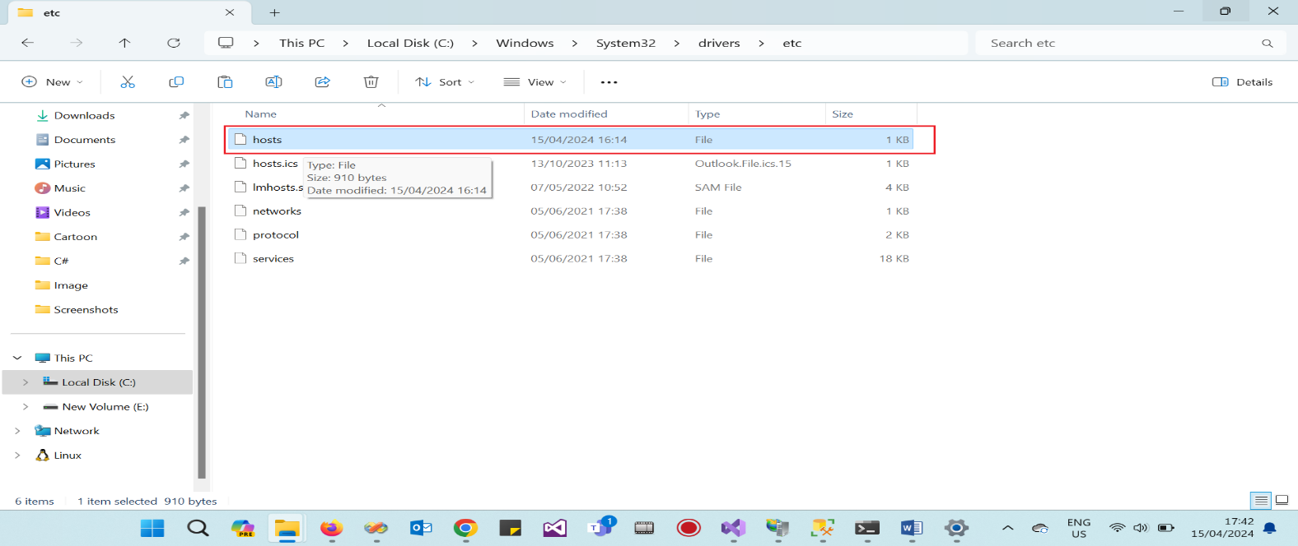

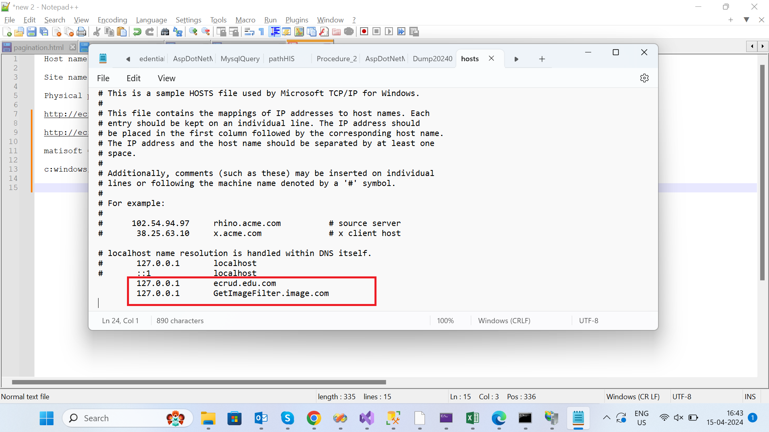

**Step : 5 –Add server name and database name appsetting json file .**

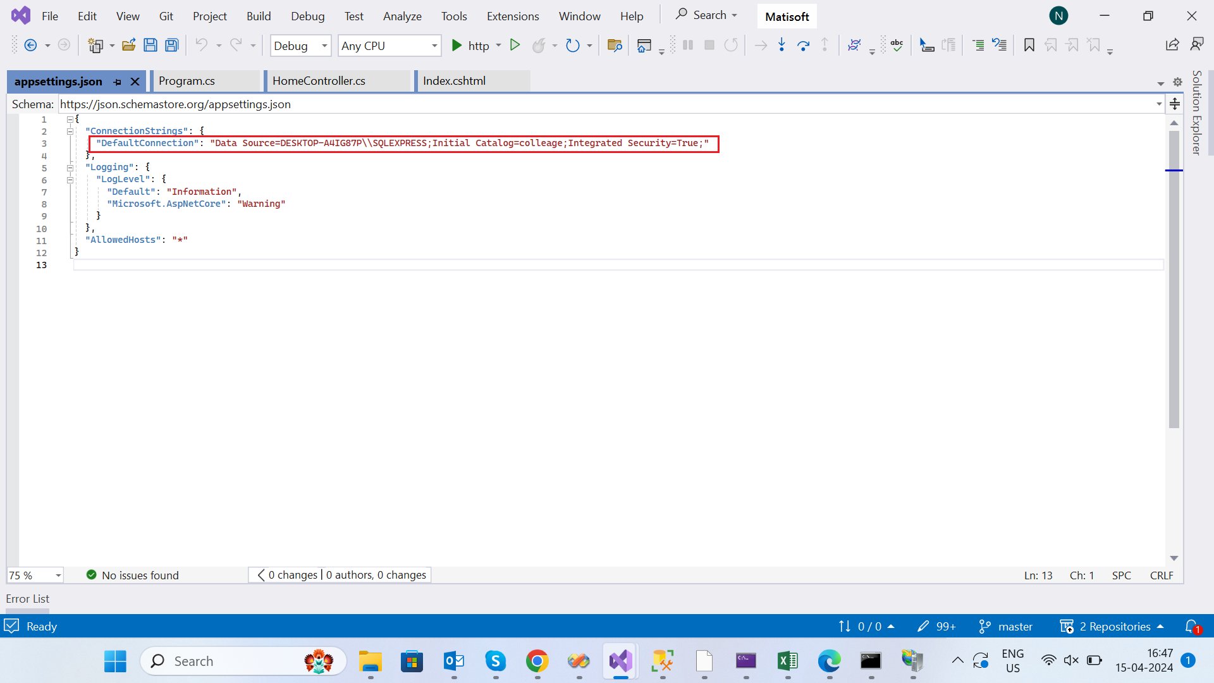

**Step : 6 –Add app.UseDeveloperExceptionPage in Program.cs file.**

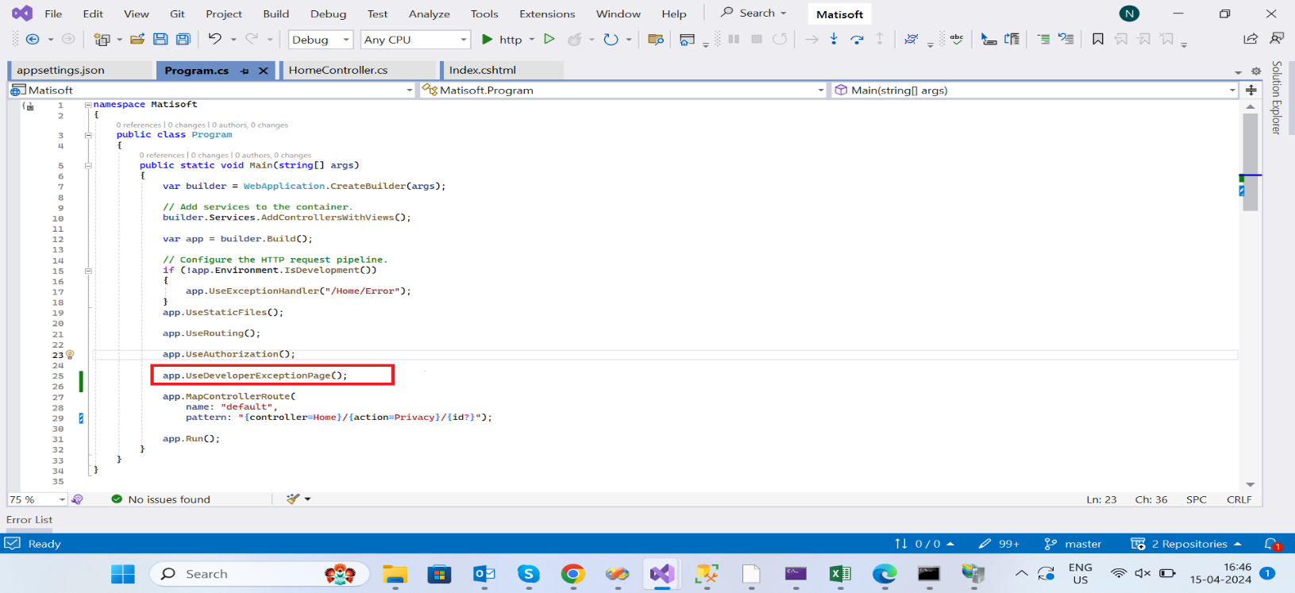

**Step : 7–Change Application Pools Defaults setting marks as blow.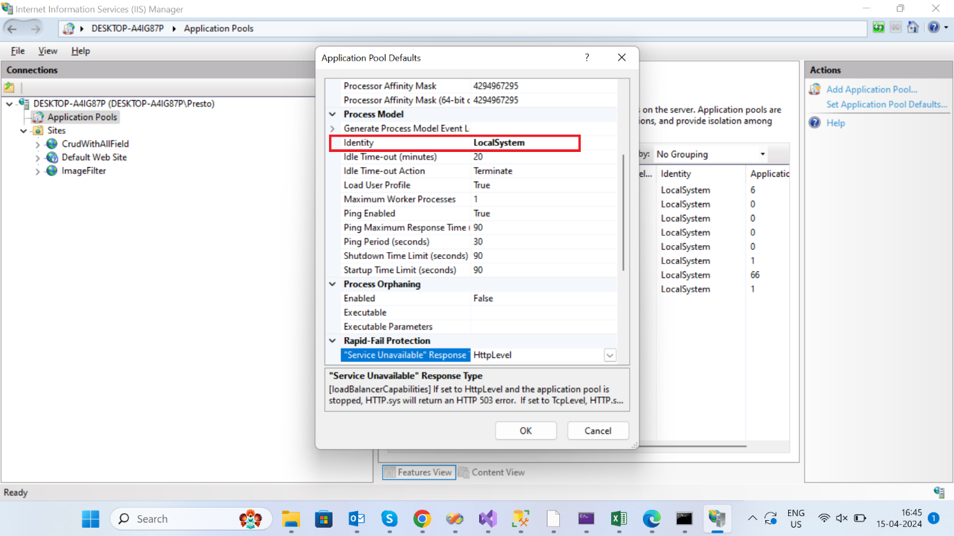Step : 8–Now Publish Your Website and Brows IIS and it is ready to Deploy and Show as blow.**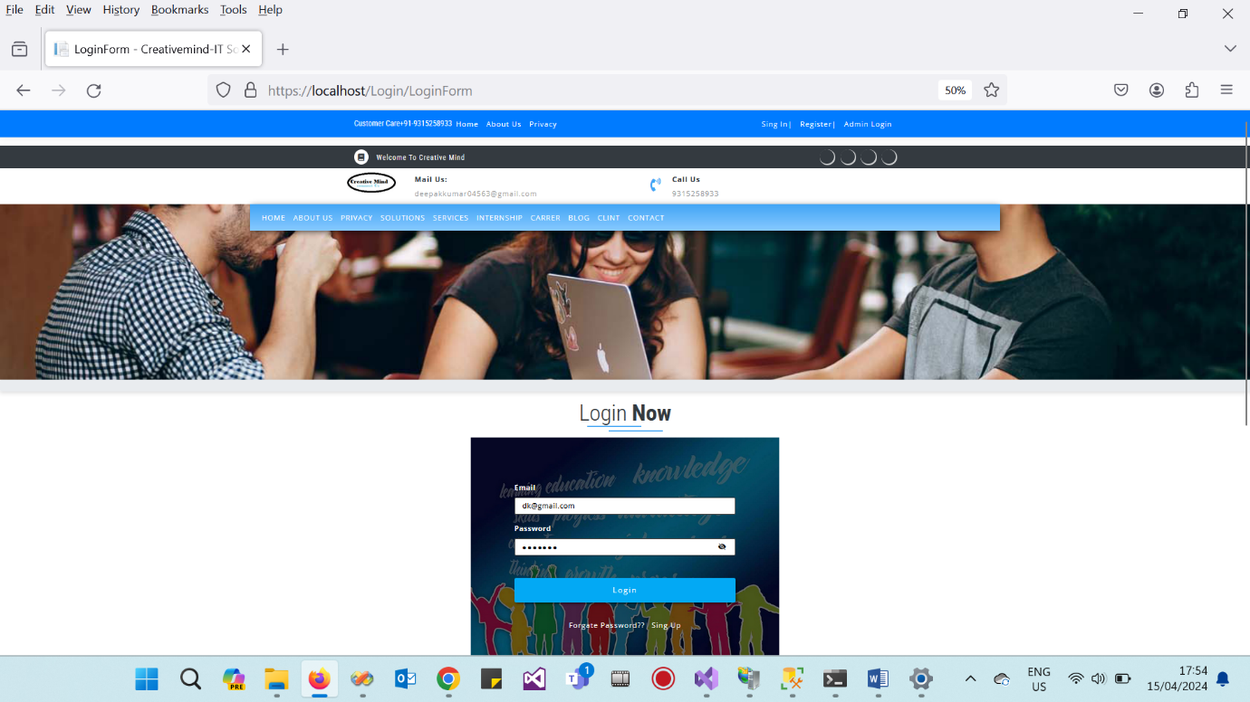

**Step : 9– If not Working install .net core hosting bundle** [**https://dotnet.microsoft.com/en-us/download/dotnet/thank-you/runtime-aspnetcore-8.0.4-windows-hosting-bundle-installer**](https://dotnet.microsoft.com/en-us/download/dotnet/thank-you/runtime-aspnetcore-8.0.4-windows-hosting-bundle-installer) **then run web**

